Least-Cost Holonomy and Co-Distinction Fields
The Shields Field of Distinct Actions: Its Definition, Its Cohomology, and the Least-Cost Selection Principle
Joseph Shields
Working paper · 28 July 2026
This paper formalises “Least-Cost Holonomy and Co-Distinction Fields: cyclic encoding, radiative distinction and self-organising field dynamics”. The earlier draft introduced a field that has no standard name and gave it an operational description. This one defines it, proves when it admits a potential, and identifies the physical condition under which it does not.
The paper is in two halves separated by a printed line. Parts One to Five use standard differential geometry, cohomology and radiative transfer, and stand or fall on that. Part Six is an extension in the author's own framework, Unified Mechanics, and is offered as interpretation. Nothing above the line depends on anything below it.
A difference between two places is not a quantity at a place. Whether it can be made into one is a question with an answer, and the answer is not always yes.

Abstract
A closed cycle in a system's internal configuration space can produce a net external displacement. This is geometric phase, and it is the mathematical basis for shape-change locomotion. The earlier draft proposed reading such a cycle as an encoder: the loop carries a required invariant into an observable output, and a variational principle selects the least-cost loop realising it. That proposal is retained and sharpened here.
The paper's new content is the definition of the second object the draft introduced and did not define. It is named here the Shields field of distinct actions, and it is not a scalar field. It is an antisymmetric two-point function 𝒟(x,y) = −𝒟(y,x) whose positive and negative orientations are the two descriptions “lighter” and “darker”, generated together by one relation. Formally it is a one-cochain, and the question of whether the pair description can be replaced by a single-point radiance L with 𝒟(x,y) = L(x) − L(y) is a cohomology question with a sharp answer.
Theorem: on a connected domain, a co-distinction field admits a radiance potential if and only if it satisfies the cocycle condition 𝒟(x,y) + 𝒟(y,z) + 𝒟(z,x) = 0 on every triple. The smooth form of the same statement is that the associated one-form is exact, with obstruction the class in the first cohomology of the domain.
The physical reading of the obstruction is the paper's second result. Transport between two points is path-independent in a purely absorbing medium and path-dependent under scattering, because radiation reaches a point from another by many routes with different optical depths. Scattering is therefore not merely a loss of directional distinction, as the draft recorded. It is the curvature of the co-distinction field, and it is exactly what obstructs the existence of a scalar radiance.
Two further results follow. The interrogative feedback loop, in which a cyclic encoder emits, the environment transforms, and the returned contrast selects the next cycle, is shown to be an operation under which the constant-holonomy class is not stable, so the least-cost principle must be stated on a refined class. And Part Six identifies the same obstruction in four separate constructions of the author's programme.
Keywords: geometric phase; holonomy; connection and curvature; co-distinction; one-cochain; cocycle condition; de Rham cohomology; radiative transfer; scattering; least-cost selection.

Part I · Cycles That Carry

1. The motivating structure
Two motions can produce the same externally recognisable result while distributing motion very differently across a system's internal degrees of freedom. The useful hypothesis is not that a circle is shorter than a line. It is that two actions equivalent at the task level may have very different lengths, energies or smoothness costs when measured in the system's internal configuration space.
Replace joints and muscles with internal coordinates a = (a¹,…,aⁿ) and observable output X = (X¹,…,Xᵐ). The question becomes which closed path through a-space produces the required change in X-space at the lowest admissible cost.
Four distinctions keep this honest, and they are stated here so they are not silently dropped later. Shortest is not always fastest, since the optimising functional decides the geometry and the brachistochrone is curved for that reason. Stationary action is not always minimal, so “least cost” is licensed only after the functional is shown to have a minimum in the admissible class. Constant momentum does not by itself produce an angular variable; phase becomes the economical coordinate when the system is recurrent or bound. And internal closure can coexist with external change.
a(T) = a(0), but X(T) ≠ X(0).
That last line is the structure everything else rests on.

2. Connection, holonomy, curvature
Let a local coupling A^α_i(a) map small internal changes to output changes, dX^α = A^α_i(a) da^i. For a closed internal loop γ the net output is the line integral
ΔX^α = ∮_γ A^α_i(a) da^i,
and in the Abelian or approximately commuting setting Stokes' theorem relates it to the curvature enclosed:
ΔX^α = ∬_Σ F^α_ij da^i ∧ da^j, F^α_ij = ∂_i A^α_j − ∂_j A^α_i.
For two internal coordinates with constant coupling B and dX = ½B(u dv − v du), Green's theorem gives ΔX = B · Area(γ) exactly. The loop returns to the same internal state and leaves a net external result. The enclosed area is not empty geometry; under the connection it measures accumulated output.
Terminological discipline. “Encoding” is used operationally: a controlled internal trajectory realises a required invariant or output. It becomes information theory only after a message space, an equivalence rule and a distortion measure are supplied. Nothing below assumes that step has been taken.
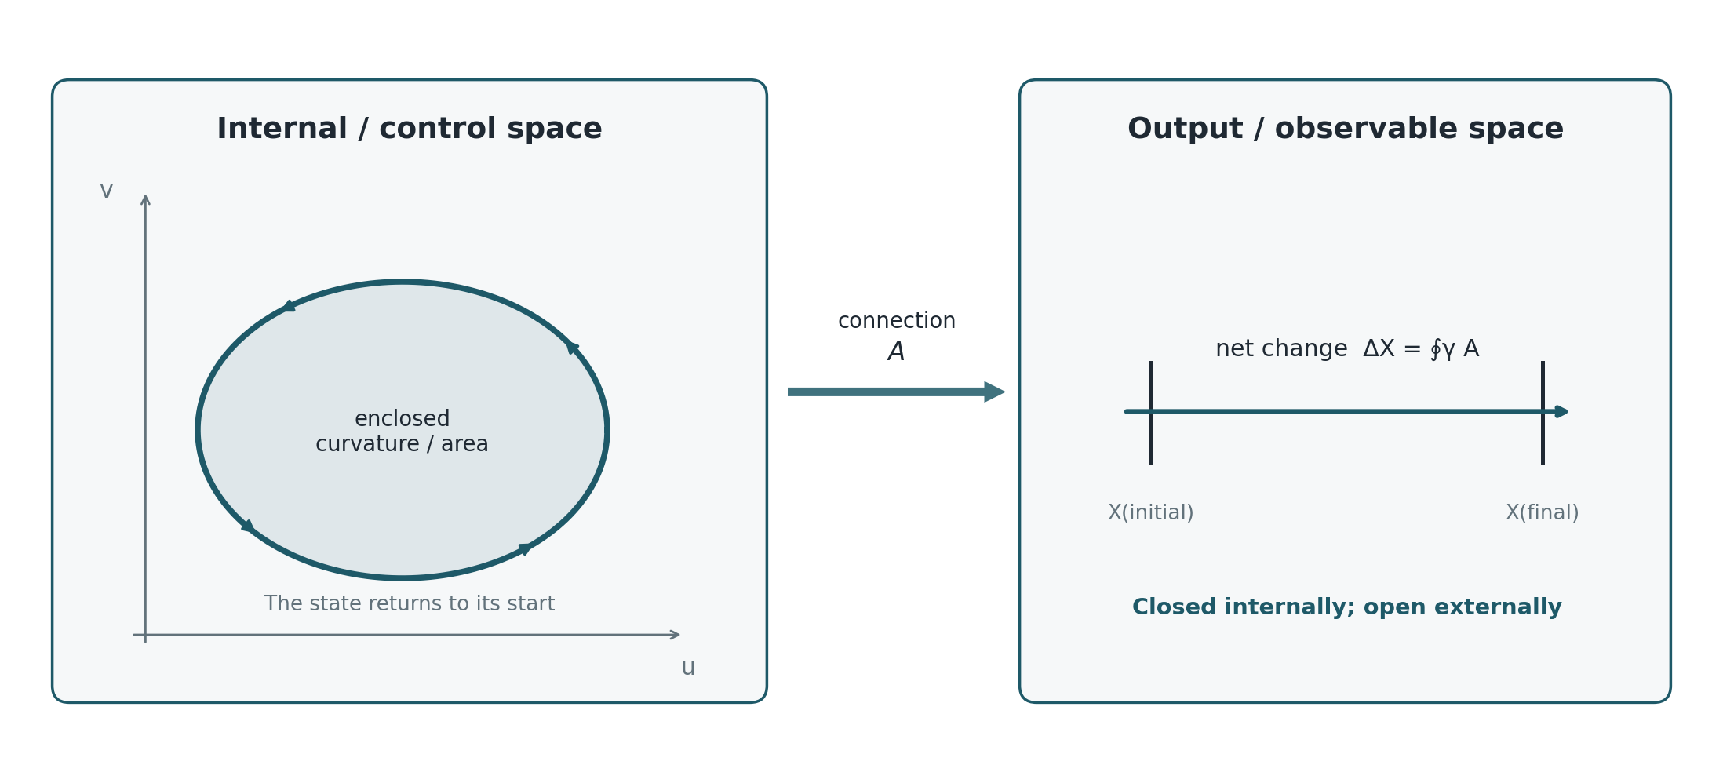
Figure 1. A closed loop in internal or control space accumulates an open displacement in output space through a connection.

Part II · The Fields, Defined

3. Three fields, and which one is new
The framework uses three field objects. Two are standard and are named here only so that the third can be stated precisely against them.
Field | Object | Status
φ(x,t) | real scalar on spacetime; the least-action background whose localised closures are the structures of interest | standard scalar field
ψ = R e^{iθ} | section of a complex line bundle with connection A; the phase θ is the internal cycle coordinate | standard, and the reading of θ as a continuum of local cyclic encoders is the reinterpretation
𝒟(x,y) | antisymmetric two-point function; the Shields field of distinct actions | new as a named object; the machinery below is standard

The first two are fields in the ordinary sense: a value is attached to each point. The third is not, and that is the whole point of it. A co-distinction attaches a value to each ordered pair of points, and it is antisymmetric under exchange. Light and darkness are its two orientations rather than two substances.

4. The Shields field of distinct actions
The object defined in this section is named the Shields field of distinct actions, and the name is chosen against the descriptive alternative. It is not a field of least action, because it does not assign a magnitude to be minimised at a point. Its primitive is the distinction between two admissible actions, held as one antisymmetric relation whose two orientations are co-produced. Where the difference between two actions composes across chains it collapses to a field of least action in the ordinary sense, and Section 5 says exactly when. Where it does not compose, the distinction is the whole of what exists, and there is no per-point action to be least. The shorter form co-distinction field is used interchangeably below.
Definition 4.1 (Shields field of distinct actions; co-distinction field). Let M be a connected domain and V a real vector space. A co-distinction field on M with values in V is a map 𝒟 : M × M → V satisfying 𝒟(x,y) = −𝒟(y,x) for all x, y. For the radiative case V = ℝ and the two orientations are read as “x is lighter than y” when 𝒟(x,y) > 0 and “x is darker than y” when 𝒟(x,y) < 0.
The antisymmetry is the formal content of the claim that the two descriptions are generated together. Reversing the comparison reverses the sign, so neither orientation is prior, and neither exists without the other being available.
Definition 4.2 (Potentiated field; the least-action reduction). 𝒟 is potentiated, or exact, if there exists L : M → V with 𝒟(x,y) = L(x) − L(y) for all x, y. L is then a potential for 𝒟, unique up to an additive constant, and is the radiance potential in the radiative case. A potentiated Shields field is precisely one that reduces to a field of least action: a single magnitude per point, of which every distinction is a difference.
A potentiated co-distinction can be replaced without loss by an ordinary scalar field. An unpotentiated one cannot, and the distinction is not a matter of convenience. It decides whether the phrase “the brightness at x” refers to anything.
Definition 4.3 (Cocycle condition). 𝒟 satisfies the cocycle condition if 𝒟(x,y) + 𝒟(y,z) + 𝒟(z,x) = 0 for every triple x, y, z in M.

5. When a co-distinction admits a radiance
Theorem 5.1. Let M be connected and 𝒟 a co-distinction field on M. Then 𝒟 is potentiated if and only if it satisfies the cocycle condition.
Proof. If 𝒟(x,y) = L(x) − L(y) then the three terms of the cocycle telescope to zero, giving necessity. Conversely, assume the cocycle condition, fix a basepoint x₀ and define L(x) := 𝒟(x,x₀). Then for any x, y the cocycle on the triple (x,y,x₀) gives 𝒟(x,y) + 𝒟(y,x₀) + 𝒟(x₀,x) = 0, hence 𝒟(x,y) = 𝒟(x,x₀) − 𝒟(y,x₀) = L(x) − L(y). Antisymmetry is the case z = x. Uniqueness up to a constant follows from the choice of basepoint. ∎
The theorem says the two-point description collapses to a one-point description exactly when differences compose. It is worth noticing what it does not require: no smoothness, no metric, no topology on M beyond connectedness. The obstruction is purely combinatorial at this level.
The smooth statement is the familiar one. Suppose 𝒟 is differentiable near the diagonal and define the one-form
ω := d_x 𝒟(x,y) |_{y = x}.
Corollary 5.2. If 𝒟 is smooth and locally potentiated, ω is closed. 𝒟 is globally potentiated if and only if ω is exact, so the obstruction is the de Rham class [ω] ∈ H¹(M;V). On a simply connected M every closed ω is exact and every locally consistent co-distinction is globally potentiated.
So a co-distinction field can be locally a difference of brightnesses and globally not a difference of anything. Around a loop γ in M the failure is measured by
∮_γ ω ≠ 0,
which is a holonomy in exactly the sense of Section 2. The connection of Part One and the co-distinction of Part Two are the same kind of object seen from two sides: one integrates a one-form to get accumulated output, the other differentiates a two-point difference to get a one-form.
A Shields field is a one-cochain. Asking whether there is a brightness, or a least action, is asking whether that cochain is a coboundary.

6. Uniformity and the degenerate case
The draft observed that a field can carry non-zero absolute radiance and contain no internal light-dark variation. In the present language that is the statement 𝒟 ≡ 0, which by Theorem 5.1 is potentiated by any constant L. The potential exists and carries no information, so no region can be classified as lighter or darker than another.
This is worth separating carefully from a stronger claim the draft was careful not to make. A vacuum or zero-radiance state remains a valid physical state in electromagnetism. The co-distinction statement concerns what becomes distinguishable inside a comparison, not what exists. The degenerate case 𝒟 ≡ 0 says the comparison returns nothing, not that the field is absent.

7. Direction, and why a scalar is not enough
For a smooth potentiated co-distinction the local direction of greatest increase is n_L = ∇L / (|∇L| + ε), so the chain runs difference → polarity → ordered gradient → direction rather than light → direction. In a full radiative description a scalar is insufficient, because radiation carries angular structure. With specific intensity I(x,n,t) the energy density and flux are
u_r = (1/c) ∫_{S²} I dΩ, F = ∫_{S²} n I dΩ,
and the directional distinction
D(x,t) := |F| / (c u_r + ε), 0 ≤ D ≤ 1,
measures angular anisotropy rather than total brightness. A bright isotropic field has u_r > 0 and F = 0. This makes precise the observation that a beam in a bright room adds little local distinction while the same beam in a dark room creates a sharp one: what changed is D and the local value of 𝒟, not the energy the beam carries.

8. Scattering is the curvature
The physical question is now sharp: when does a radiative co-distinction fail the cocycle condition? The answer is available from ordinary transport theory.
Define 𝒟(x,y) by the radiation transported from y to x, so that 𝒟 is built from the transfer between the two points. Along a ray the equation of transfer is
(1/c) ∂_t I + n·∇I = −κ I + j + 𝒮[I],
with κ absorption, j emission and 𝒮 the scattering operator. Consider the two limiting cases.
In a purely absorbing and emitting medium with 𝒮 = 0, radiation reaches x from y along the unique straight ray between them, attenuated by the optical depth of that ray. The transfer between any two points is single-valued, differences compose along chains, and the cocycle condition holds. The co-distinction is potentiated and a scalar radiance exists.
With 𝒮 ≠ 0 radiation reaches x from y along many routes of different optical depth, and the contribution is a sum over paths rather than a value on one. Composing x to z to y need not agree with x to y directly, because the intervening scattering redistributes the angular content on which the comparison depends. The cocycle condition fails, and by Theorem 5.1 no radiance potential exists.
A purely absorbing medium has a brightness. A scattering medium has only differences.
Corollary 8.1. The obstruction to a scalar radiance is carried by the scattering operator. In the notation of Corollary 5.2, 𝒮 = 0 implies [ω] = 0.
This recasts a statement the draft made in energetic terms. It recorded that scattering preserves total radiative energy while redistributing it over angles, so that |F| falls and directional distinction is lost. That is correct and it is the shadow of a stronger fact. Scattering does not merely reduce D. It destroys the composability of differences, and with it the existence of the single-point quantity that the whole scalar description presupposes.
Theorem 5.1 and Corollary 5.2 are PROVED and are standard cohomology stated for this object. Corollary 8.1 is PROPOSED at the level of the limiting cases argued above: the absorbing case is established, and the scattering case is argued from multiplicity of transport paths rather than from a computed cohomology class for a specified scattering kernel. Computing [ω] for a named kernel is the first open problem of this paper.
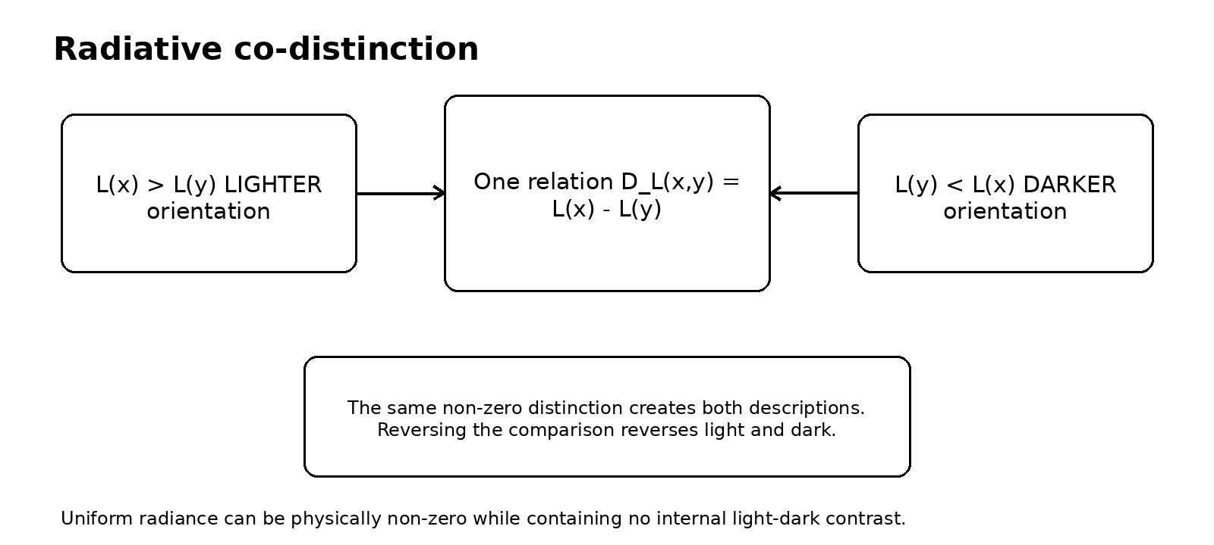
Figure 2. Light and darkness as the two orientations of one radiative distinction. The same non-zero relation creates both descriptions; reversing the comparison reverses them.

Part III · Selection

9. The Least-Cost Holonomy Principle
Assign the internal configuration space a positive metric g_ij(a). The geometric articulation cost of a loop and a time-parametrised effort cost are
C_ℓ[γ] = ∮_γ √(g_ij da^i da^j), C_e[a] = ∫₀^T ½ g_ij(a) ȧ^i ȧ^j dt.
The metric can encode unequal actuator effort, viscosity, inertia, smoothness penalties or field stiffness, so the motivating intuition becomes a statement about anisotropic distance in control space rather than a claim about counting muscles.
Let I[γ] denote the invariant accumulated by the cycle. The principle is a constrained optimisation,
minimise C[γ] subject to I[γ] = I₀, equivalently δ{ C[γ] − λ(I[γ] − I₀) } = 0.
Least-Cost Holonomy Principle. Among all admissible closed internal cycles that realise the required external invariant, the physical cycle is a stationary point of the system's actual control cost.
Under an isotropic length cost with a constant curvature coupling the solution is the isoperimetric one, and the circle is optimal because it encloses the most area per unit boundary. Under an anisotropic metric it is not, and the optimal loop is whatever shape the metric makes cheap. That is the honest form of the claim that circles appear: they appear when the cost is isotropic, and they do not otherwise.

10. The logical layer and the physical layer
The principle separates two constraints that are usually mixed.
Layer | Question | Mathematical role
Logical or task | What counts as the same successful result? | I[γ] = I₀ defines the equivalence class
Physical | Which realisation is admissible and least costly? | C[γ] and the equations of motion select within it

The separation is the useful feature of the framework, because it lets a system preserve abstract content while changing the physical path that instantiates it. It is also the structure that the next part tests, because I[γ] = I₀ is a quotient and quotients are safe only under conditions.

Part IV · Interrogation, and the Stability of the Class

11. The interrogative loop
A structure that emits is not yet interrogative. It becomes one when the emitted distinction passes through the environment and the structure's subsequent state depends on how that distinction was transformed. The minimal loop is
emit → interact → return → compare → respond.
Let the cyclic encoder be ψ = R e^{iθ} sourcing a directional intensity through an emission functional j[ψ,n] in the transport equation of Section 8. The environment enters through κ, the scattering kernel, boundary conditions and refractive structure. The returned radiation is summarised by u_r, F, D, ω or a comparison between emitted and received angular distributions. A minimal response is
∂_t ψ = −Γ δℱ/δψ* + χ ℛ[I;ψ] ψ + 𝒩_active[ψ,r],
with the first term relaxing under a passive free energy, the second letting environmental contrast change local growth, phase or motion, and the third carrying pumping and resource use.
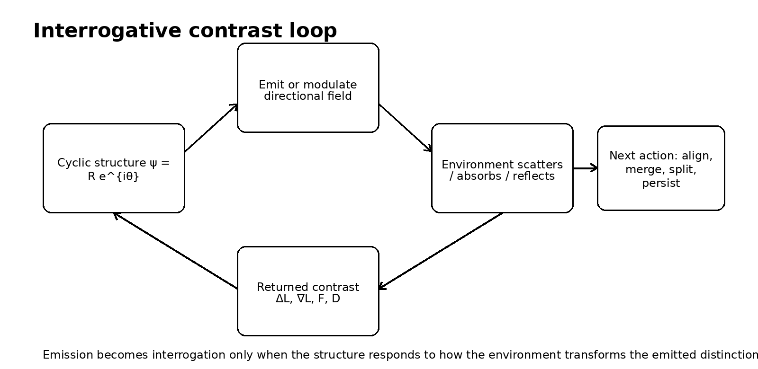
Figure 3. A cyclic encoder closes its dynamics through an interrogative contrast loop.

12. The holonomy class is not stable under interrogation
The draft proposed a combined objective
𝒥 = 𝒞[ψ] − λ ℋ[ψ] − η 𝒬[I,ψ],
with 𝒞 the physical cost, ℋ the required holonomy and 𝒬 the acquired directional distinction. Written this way the three terms look parallel. They are not, and the difference decides whether the principle of Section 9 is well posed once interrogation is switched on.
ℋ is constant on the class of loops realising the required invariant; that is what makes it a constraint. 𝒬 is not. The emission functional j[ψ,n] depends on the trajectory of ψ around the loop and not on the enclosed holonomy alone, so two loops with identical ℋ generically emit different angular distributions, receive different transformations from the environment, and return different 𝒬.
Proposition 12.1. Let Φ denote one pass of the interrogative loop. If 𝒬 separates two loops of equal holonomy, then the equivalence classes of the map γ ↦ ℋ[γ] are not stable under Φ, and no selection rule defined on holonomy alone reproduces the outcome of Φ for both loops.
Proof. Two loops in one class present the same input to any rule defined on the class, so a deterministic rule returns the same output for both. If their post-interrogation states differ, the single output is wrong for at least one. ∎
The consequence is not that the least-cost principle fails. It is that the invariant which gets constrained must carry the emission history and not only the enclosed area. On the refined class the principle is well posed again, and on the unrefined class it is well posed only for operations that see nothing but the holonomy.
The holonomy is what the loop delivers. It is not what the loop did, and interrogation asks the second question.
Proposition 12.1 is PROVED and elementary. Whether 𝒬 in fact separates loops of equal holonomy for a specified emission functional is a calculation that has not been done here, and it is the second open problem of this paper.

Part V · The Field Programme

13. From one cycle to a continuum
A continuum of local cyclic encoders is naturally described by a complex amplitude-phase field ψ = R e^{iθ}, with localised rotating regions connecting structurally to soliton and Q-ball models. A U(1) symmetry supplies a Noether current, and winding or charge density becomes a candidate measure of encoded structural content subject to strict symmetry and topology requirements.
Where the Shields field is potentiated, the background scalar φ is its potential, and φ carries the least-action closures at multiple scales, with localised density ρ_m = |ψ|² and field slope g_φ = −∇φ, and phase fronts propagating along the slope. That is the picture the draft's summary figure records, and it is retained here as a programme rather than as a result.
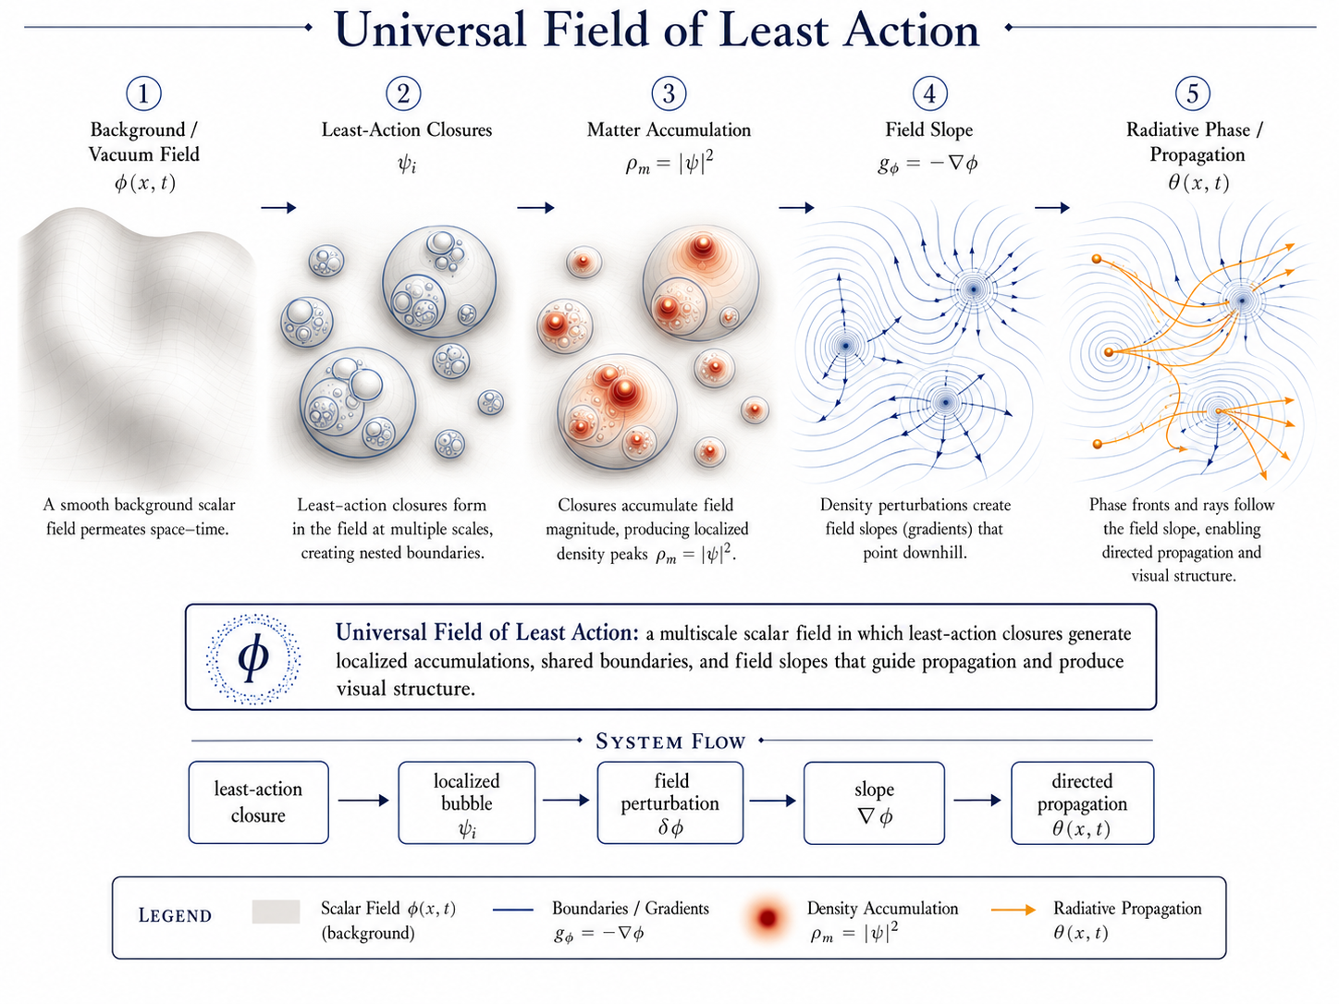
Figure 4. The programme, drawn in the potentiated case. Least-action closures in the potential φ generate localised accumulations, shared boundaries and field slopes that guide propagation. Where the Shields field is not potentiated, φ does not exist and only the closures and their differences do.

14. What replication does and does not follow from
One correction must be preserved because it is easy to lose. Least action alone does not imply self-reproduction. Conservative action principles yield persistence, oscillation and localisation. Repeated splitting or replication normally requires a driven, dissipative or unstable pattern-forming system, and the reaction-diffusion experiments that exhibit self-replicating spots supply the replication through non-equilibrium chemistry rather than through least action in isolation.
The action language therefore covers the passive core, and the active terms of Section 11 supply the open-system dynamics. Merging, splitting and replication are then distinct outcomes of one feedback architecture, with resource and inheritance conditions stated explicitly rather than assumed.

15. Status ledger
Statement | Status | Note
Closed internal loops produce net external holonomy | established | geometric mechanics
Loop output relates to enclosed curvature | established | exact in the Abelian case
Cost metrics optimise cyclic gaits | established | supports least-cost selection
Shields field is potentiated iff cocycle holds | proved here | Theorem 5.1
Obstruction is the class [ω] in H¹ | proved here | Corollary 5.2
Scattering obstructs a scalar radiance | proposed | Corollary 8.1, limiting cases only
Holonomy classes unstable under interrogation | proved here | Proposition 12.1
Replication follows from least action | not claimed | requires driven dynamics
The field is a known fundamental interaction | not claimed | no such identification is made

ABOVE THIS LINE: STANDARD GEOMETRY, COHOMOLOGY AND RADIATIVE TRANSFER
BELOW THIS LINE: THE AUTHOR'S OWN FRAMEWORK, OFFERED AS INTERPRETATION

Part VI · Extension · One Obstruction, Four Presentations

16. The line, and what is below it
Everything above uses standard differential geometry, standard cohomology and standard radiative transfer. Theorem 5.1 is a telescoping argument, Corollary 5.2 is de Rham, Proposition 12.1 is the pigeonhole applied to a deterministic map. A reader who rejects what follows keeps all of it.
What follows is the author's own framework, and the Corpus grades apply: PROVED, CONDITIONAL, PROPOSED, OPEN.

17. The same obstruction, four times
This paper is the fourth in a programme, and the reason for the extension is that the four have converged on one object without being designed to.
Paper | The closed thing | What fails to descend
The Depth of Traversal | the timelike curve, γ(T) = γ(0) | proper time; Δτ = ∮ of the metric form
Chiral Wave to PLA | the bulk Euler–Lagrange class | the boundary term; the topological class
This paper, Part II | the comparison triangle | the potential of the Shields field; [ω] ∈ H¹
This paper, Part I | the internal cycle, a(T) = a(0) | the output; ΔX = ∮A

In every row a quantity is closed on the base and fails to descend to it. The defect around a loop is a holonomy; the defect as a class is a cohomology class. Nothing is wrong with any of the base descriptions. Each is flat where the object it describes is not.
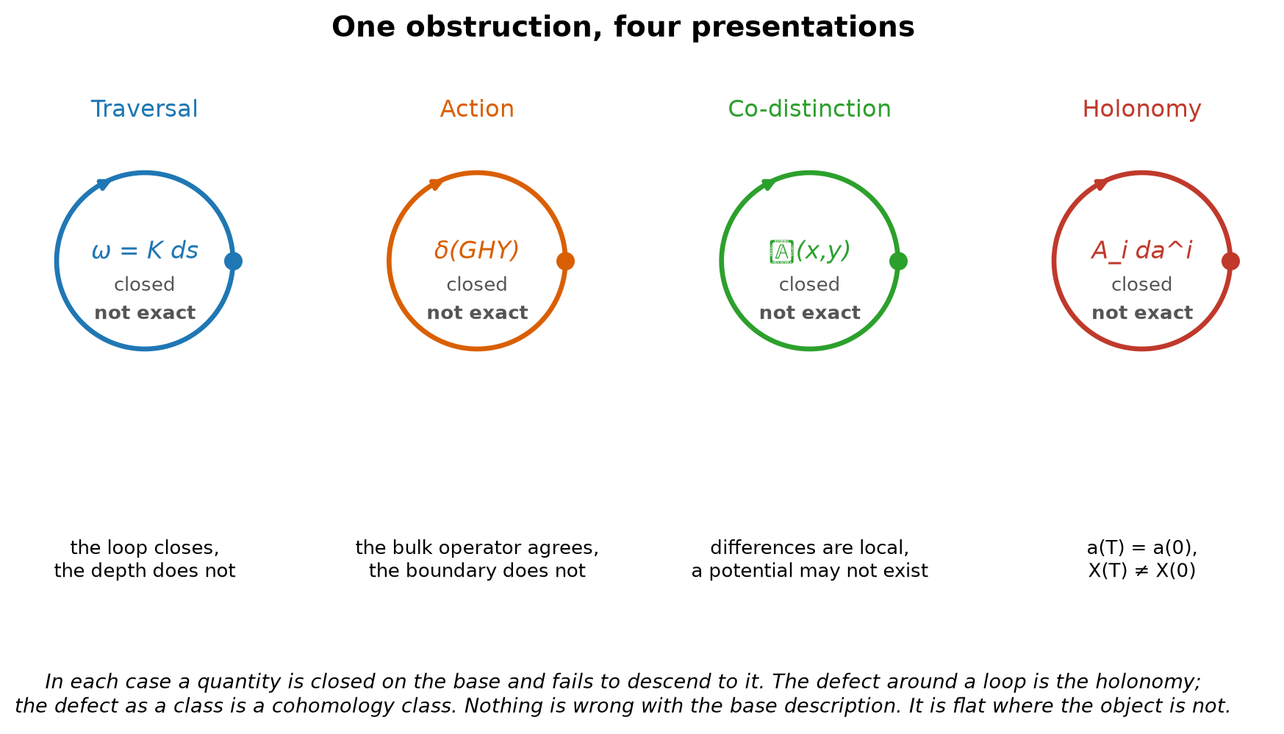
Figure 5. One obstruction in four presentations. In each case the base closes and the accumulated quantity does not.
Closed but not exact. That is the whole programme in three words, and it is standard mathematics rather than the author's.

18. What the framework adds to it
If the obstruction is standard, the question is what remains for the framework, and the answer is three things that the mathematics does not supply.
Which coordinate. The mathematics permits any fibre. The Register's T15 proves the order of accumulation is single, because two independent orders would be two records and therefore two systems, so the lift adjoins one coordinate rather than an arbitrary number. That is the same result used in the traversal papers and in the logical-action paper, and it is one identification serving three.
Which direction. A general connection has holonomy of either sign. The traversal condition K ≥ 0 makes it sign-definite, and a sign-definite holonomy is an arrow rather than a phase. The Shields field of Part Two is the case where the sign is not fixed, which is why light and dark are two orientations of one relation and neither is prior. The two cases are the same geometry with and without an arrow, and the framework says which physical situations get one.
Which loop. The mathematics says the holonomy is what it is. Section 9 adds a selection principle: among the loops realising it, the physical one is stationary in cost. That is the piece the earlier papers of the programme did not have, and it is this paper's contribution to them.
The identification of the traversal lift, the logical-action refinement and the co-distinction potential as one obstruction is PROPOSED. It is supported by the four constructions having the same form and by three of them being derived independently before the fourth was written. The rank-one claim is CONDITIONAL on T15 as in the companion papers, and it is the same single identification, not a fourth one.

19. What is owed
Two calculations and one identification. The cohomology class of a named scattering kernel, which would move Corollary 8.1 from proposed to settled. Whether 𝒬 separates loops of equal holonomy for a specified emission functional, which would settle Proposition 12.1's premise. And the identification named in the companion papers, that the retained order of these constructions is the Register's single order of accumulation, which this paper inherits and does not add to.
What would end it. A scattering medium in which differences do compose, contradicting Corollary 8.1. An interrogative architecture whose response depends only on holonomy, making Proposition 12.1 vacuous. Or a demonstration that the four presentations of Section 17 are related only by analogy, which would be shown by exhibiting one of them in which the defect is not a cohomology class.

20. Closing
The earlier draft named a field and described how it behaves. The field is an antisymmetric two-point function, its two orientations are one relation, and whether it can be replaced by a brightness is a cocycle question with a proof either way. Where a medium scatters, it cannot be, and the failure is not a loss of contrast but the absence of the quantity that contrast was supposed to be a difference of.
That result stands on its own. It also happens to be the fourth time this programme has met the same structure: something closes, something else does not descend, and the gap between them is where the physics was.
A difference between two places becomes a quantity at a place only when differences compose. Where they do not, the difference is all there is, and it is not less real for having no least action to be least.

References
1. Marsden, J. E. and Ratiu, T. S. (1999). Introduction to Mechanics and Symmetry, 2nd ed. Springer.
2. Shapere, A. and Wilczek, F. (1989). “Geometry of Self-Propulsion at Low Reynolds Number.” Journal of Fluid Mechanics 198, 557–585.
3. Berry, M. V. (1984). “Quantal Phase Factors Accompanying Adiabatic Changes.” Proceedings of the Royal Society A 392, 45–57.
4. Bott, R. and Tu, L. W. (1982). Differential Forms in Algebraic Topology. Springer. De Rham cohomology and the exactness obstruction.
5. Chandrasekhar, S. (1960). Radiative Transfer. Dover Publications.
6. Mihalas, D. and Weibel-Mihalas, B. (1984). Foundations of Radiation Hydrodynamics. Oxford University Press.
7. Pearson, J. E. (1993). “Complex Patterns in a Simple System.” Science 261, 189–192.
8. Lee, K.-J., McCormick, W. D., Pearson, J. E. and Swinney, H. L. (1994). “Experimental Observation of Self-Replicating Spots in a Reaction–Diffusion System.” Nature 369, 215–218.
9. Coleman, S. (1985). “Q-Balls.” Nuclear Physics B 262, 263–283.
10. Shields, J. (2026). “The Depth of Traversal.” Working paper. Cited in Part Six.
11. Shields, J. (2026). “From Chiral Wave Evolution to the Principle of Logical Action.” Working paper. Cited in Part Six.
12. Shields, J. (2026). Unified Mechanics, Corpus Edition, Fifth Printing. Formal Register, T15. Cited in Part Six.

